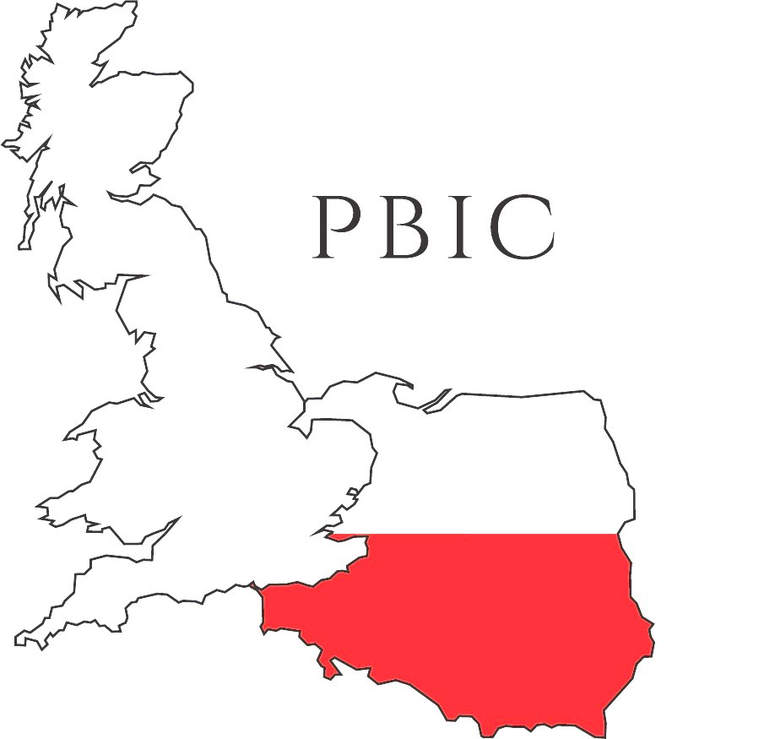
Polish British Integration Centre
Ośrodek Integracji Polsko Brytyjskiej

Volunteer expression of interest form

Title
Name
Address
Telephone
E-mail address
Where have you heard about PBIC?
Why would you like to work as a volunteer for PBIC?
What kind of skills can you offer as a volunteer?
How many hours can you offer as a volunteer?

Thank you for expressing your interest in volunteering for PBIC.
You will be contacted by a PBIC manager soon to arrange an interview.
Polish British Integration Centre, 1 Lurke Street, Bedford MK40 3TN, United Kingdom,
PBIC is registered as a Charity Organisation Reg. no. 1152448. Company no. 06632086

